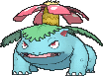
TEAM VENASAUR
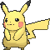
TEAM PIKACHU
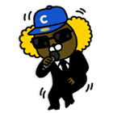
TEAM JAY-G
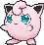
TEAM JIGGLYPUFF
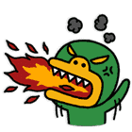
TEAM TUBE
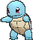
TEAM SQUIRTLE

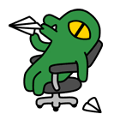
TEAM CON
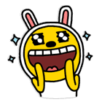
TEAM APEACH
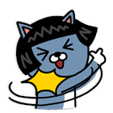
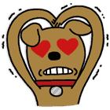
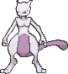
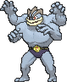
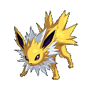
TEAM MUZI
TEAM CHARMANDER
TEAM NEO
TEAM JOLTEON
TEAM FRODO
TEAM FACE

TEAM MACHAMP

TEAM MEWTWO

