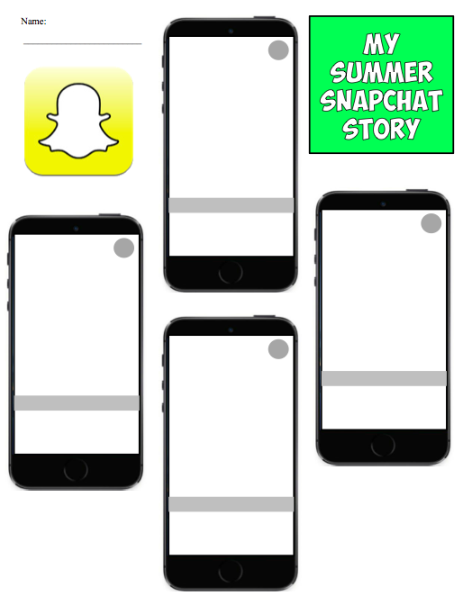

**My Trip**

**Snapchat**

**Story**

I went to ________________________ ______________________________.

I liked __________________.

I was _________________ (happy, angry, sad, excited).

I saw __________________.

I traveled by _____________ (bus, car, plane).