Birthday (생일)  ____ /____ /____  Nationality (국적)  __________________  My Favorite color (내가 가장 좋아하는 색):  _____________________  My Favorite food (내가 가장 좋아하는 음식):  _____________________  My Favorite subject (내가 가장 좋아하는 과목)  _____________________ |  |  |  |  |  | 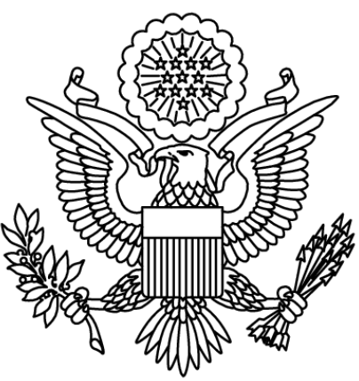  Stamp Passport  여권 도장
My Hobbies (나의 취미들):  _____________________________________________  _____________________________________________  Signature (서명/사인): |  |  |  |  |  | Name: _______________________  Class: ____학년 ____반
 |  |  | candy | FOLD |  |  |  |  | candy
 |  |  | candy |  |  |  |  |  | candy
 |  |  | sticker |  |  |  |  |  | sticker
 |  |  | candy |  |  |  |  |  | candy
 |  |  | candy |  |  |  |  |  | candy

