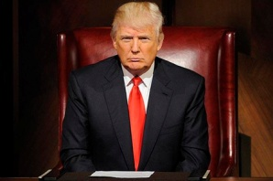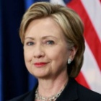

**Election Ballot**

**Election Ballot**

**Election Ballot**

**Election Ballot**

**Election Ballot**

**Election Ballot**

**Election Ballot**

**Election Ballot**

**Election Ballot**

Donald Trump

Hillary Clinton

Hillary Clinton

Donald Trump

Hillary Clinton

Donald Trump

Hillary Clinton

Hillary Clinton

Donald Trump

Donald Trump

Hillary Clinton

Donald Trump

Donald Trump

Hillary Clinton

Hillary Clinton

Donald Trump

Hillary Clinton

Donald Trump

Hillary Clinton

Donald Trump

**Election Ballot**