Cut so each item is its own slip of paper

•Pack of 6 boxes, containing 50 matches each
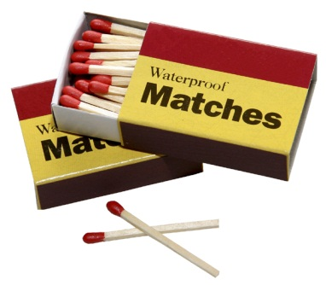
•Heavy duty tarp 12 feet x 14 feet
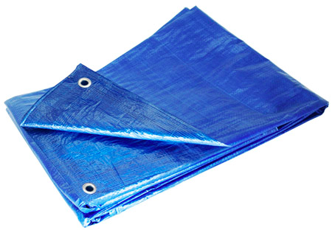
•1 case of soda (12 cans in total)
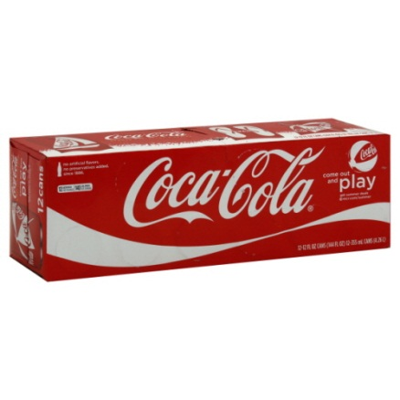
•Mosquito net
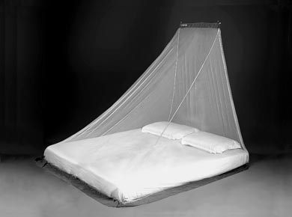
•Small toolbox containing hammer, screwdriver set,
adjustable wrench, hacksaw and large penknife.
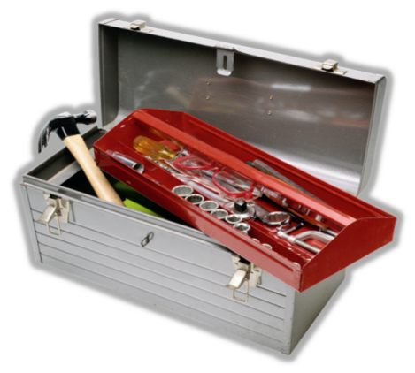
•Box of distress signal flares.
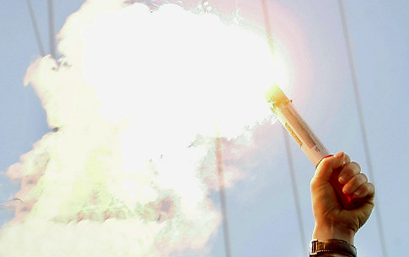
•Small basic first-aid kit containing plasters, bandages,
antiseptic ointment, small pair of scissors and painkiller tablets.
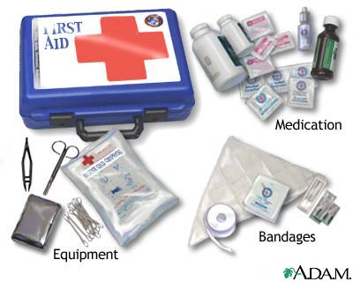

•Mobile phone and battery half-charged.
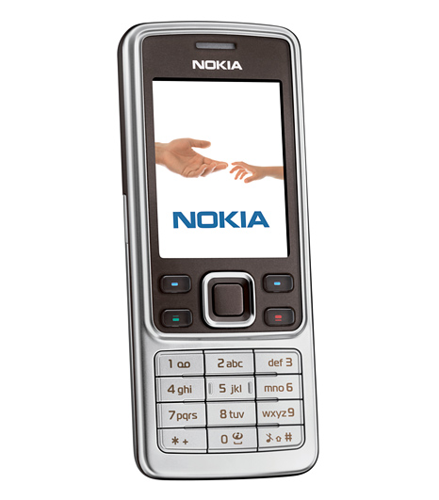
•Clockwork transistor radio.
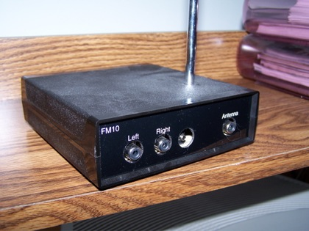
•5 gallons full of fresh water.
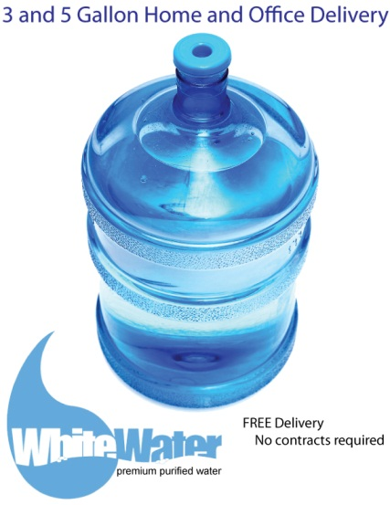
•Box of 24 chocolate bars. 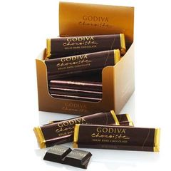

•Shovel.
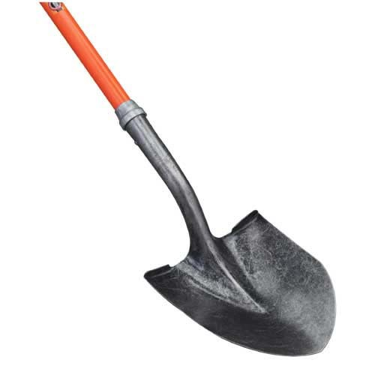
•Small radio
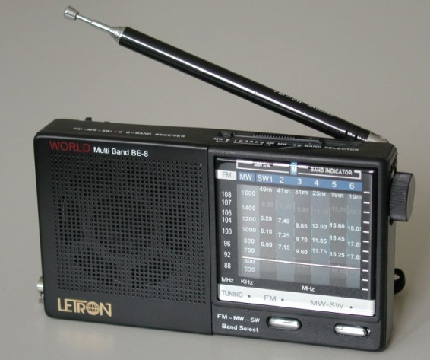
•Floating seat cushion
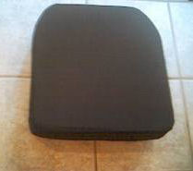
•Short hand-held axe.
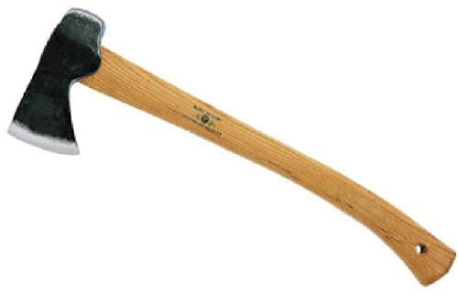
•One box of canned food
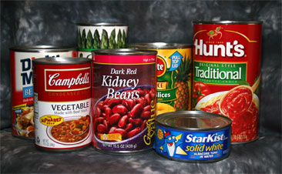

•Handgun with magazine of 20 rounds.
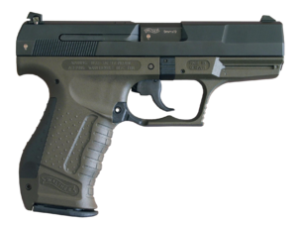

•100 feet, nylon rope.
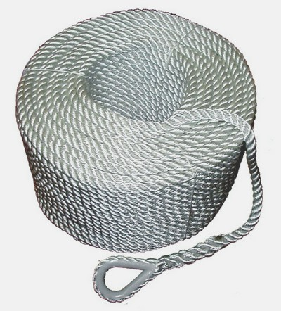

•Box of 24 bags of peanuts.
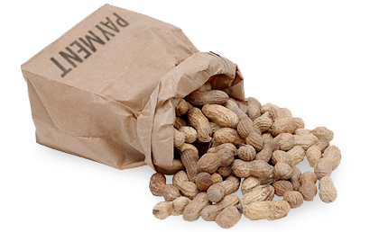
•Bag of 10 newspapers.

•Box of tissues.
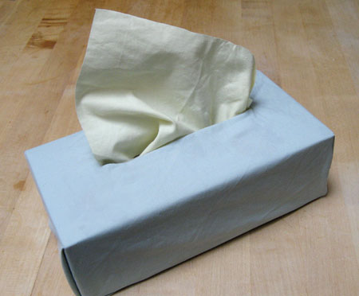
•Fishing kit
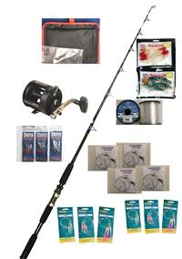

•Electronic calculator.
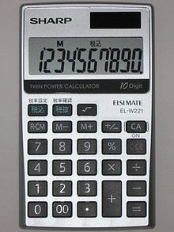
•Map of the Pacific Ocean
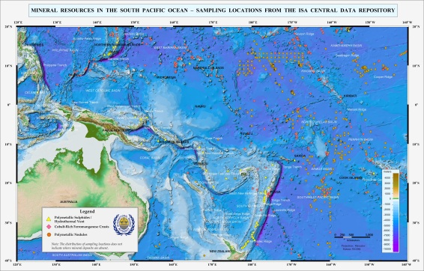
•Laptop computer with ,
unknown software and data, and unknown battery life.
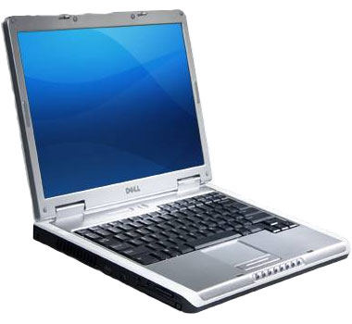

•Compass.
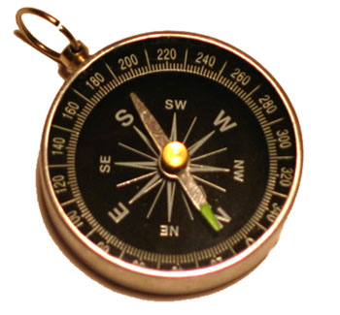

•Shaving mirror
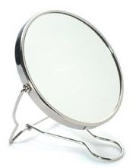
•One bottle of alcohol
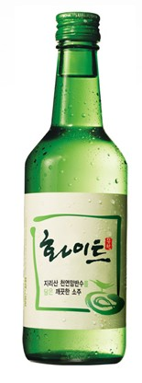

•Large full Aerosol can of insect spray.
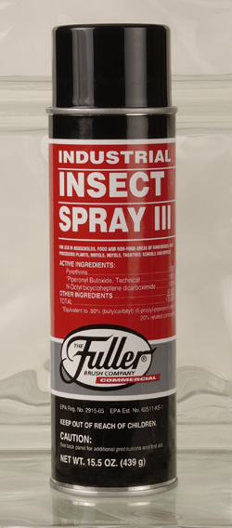

•Small half-full aerosol can of air freshener spray.
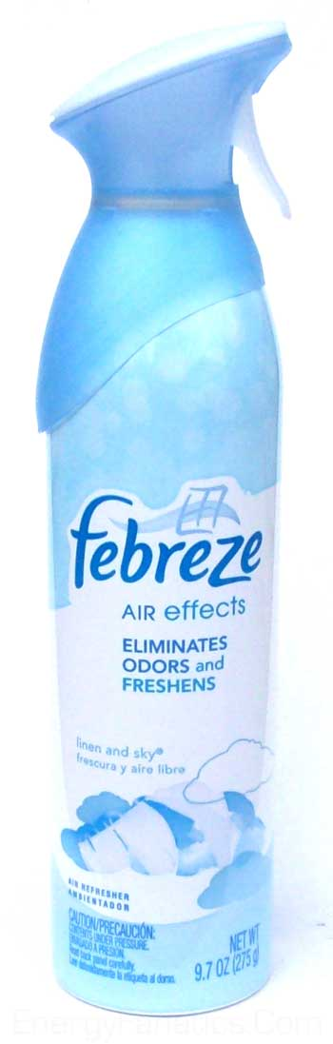
•Notebook and pencil.
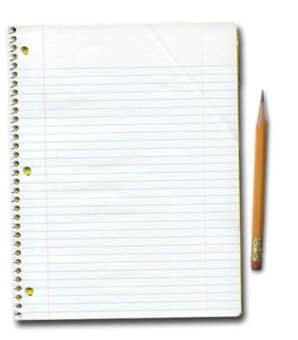

•Box of with 8 fleece-lined track-suits
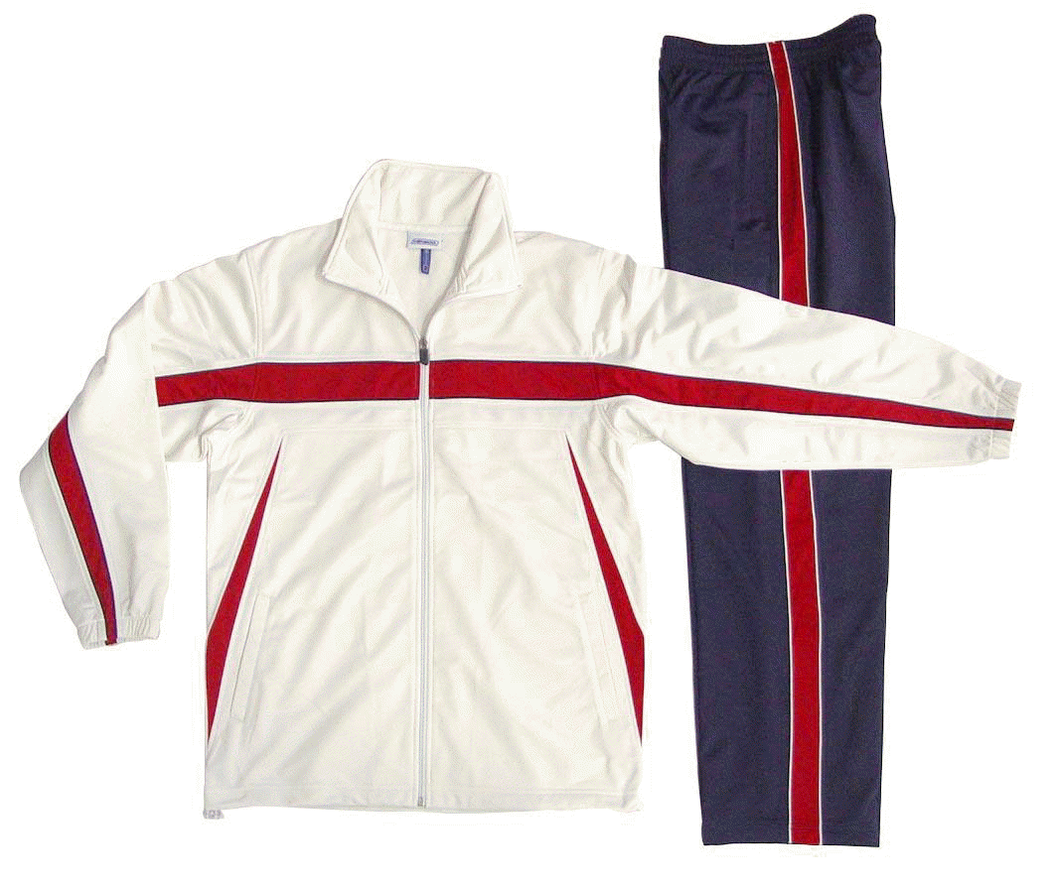

•Gift hamper containing half-bottle champagne,
large tin of luxury cookies, box of 6 pies, three boxes
of chocolate, cheese, and a Loaf of bread.

•Traveling games collection containing chess,
backgammon and a deck of cards.
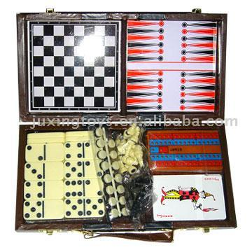
•Sewing kit.
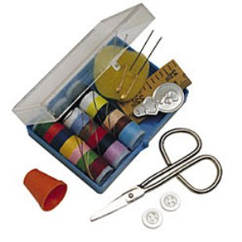

•2 gallons of oil
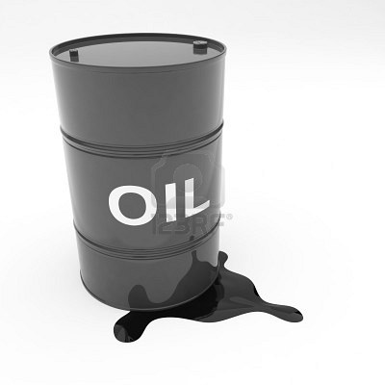
•Whistle.
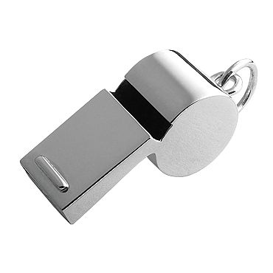

•Flashlight with a set of spare batteries.
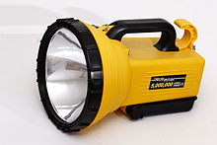

•Box of 50 candles.
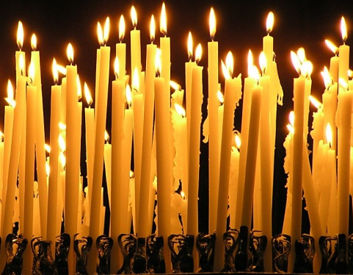
•Bag of 6 large blankets.


