Let It Go
Idina Menzel

The snow glows white on the ____________ tonight
Not a _______________ to be seen
A kingdom of isolation
And it looks like I'm the ____________

The wind is howling like this swirling ________ inside
Couldn't keep it in, heaven knows I tried.
Don't let them _______, don't let them ______
Be the good girl you always have to be
Conceal, don't ________
Don't let them know
Well, now they know!

Let it go, let it go!
Can't hold it back _____________
Let it go, let it go!
Turn away and ________ _______ ________
I don’t ________ what they're going to say
Let the storm rage on
The cold never ______ me anyway

It's funny how some __________
Makes _______________ seem small
And the fears that once controlled me
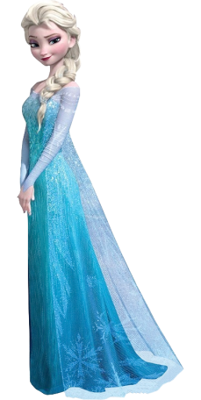
Can't get to me at all

It's time to see what I can do
To _______ the limits and break through
No right, no wrong, no rules for me
I'm _________!

Let it go, let it go!
I am one with the ________ and ________
Let it go, let it go!
You'll never see me _______
Here I'll _________ and here I'll stay
Let the storm rage on

My power flurries through the air into the ___________
My soul is __________in frozen fractals all around
And one ___________ crystallizes like an icy blast
I'm never going back
The past is in the _________!

Let it go, let it go!
And I'll _________ like the break of dawn
Let it go, let it go
That ____________ girl is gone
Here I stand in the light of day
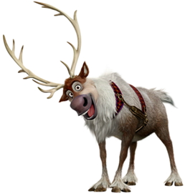
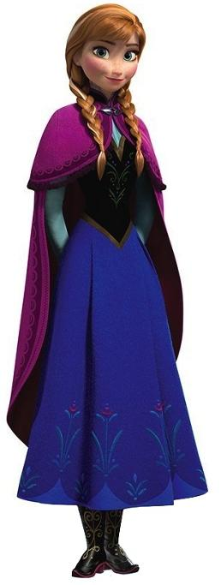
Let the __________ rage on!
The cold never _____________ me anyway
