[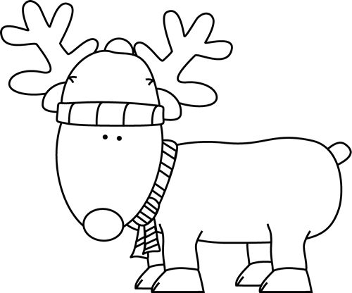](https://www.google.co.kr/url?sa=i&rct=j&q=&esrc=s&source=images&cd=&cad=rja&uact=8&ved=0ahUKEwib1cbVzbnJAhXB2qYKHWAvAZoQjRwIBw&url=https://www.pinterest.com/pin/421860690067010910/&psig=AFQjCNHkRYoCyg17FfMEarKwCrC5purX5A&ust=1449023028606231)

