Thanksgiving Scavenger Hunt
 | Location (장소) | Floor  (층)
Turkey
Pilgrims
Native American Indian
Thanksgiving Parade
Football
Stuffing
Cranberries
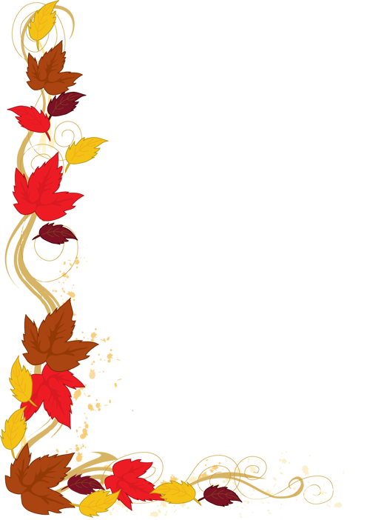
Sweet Potatoes
Mashed Potatoes
Gravy

Bonus Questions
- When was the first Thanksgiving? (+2)
- What are 2 Thanksgiving desserts? (+1)
- What are 2 Thanksgiving vegetables? (+1)
- Where in America is the Thanksgiving Parade? (+1)

